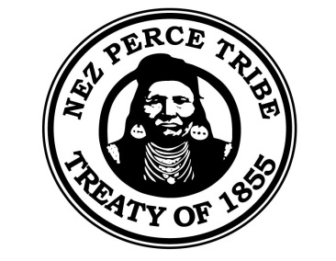
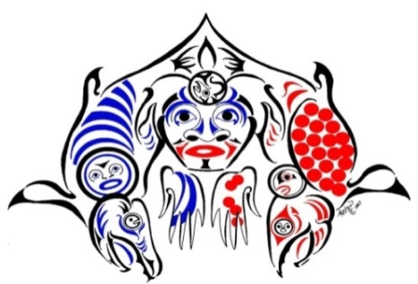
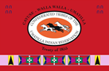

65th Annual
Northwest Fish Culture Conference
“Restoring Native Species in the Pacific Northwest”

December 2 – 4, 2014
Wildhorse Resort and Casino – Pendleton, Oregon

Dear Fish Culture Associates:

This is your invitation to attend the 65th Annual Northwest Fish Culture Conference (NWFCC), December 2 – 4, 2014. The Confederated Tribes of the Umatilla Indian Reservation and the Nez Perce Tribe are pleased to be hosting this event at the Wildhorse Resort and Casino in Pendleton, Oregon. We look forward to seeing you at this year’s conference and the presentations highlighting our 65th annual NWFCC theme.

This conference continues to be extremely educational and beneficial for everyone attending, presenting, and exhibiting fish culture products. Go directly to 123 Signup https://www.123signup.com/register?id=yghcf or visit the conference website http://nwfcc2014.magix.net to register online with secure credit card payment options. We strongly encourage delegates to register and pay online, but will also accept mail-in registrations.

We recommend early conference registration as attendance is generally very strong and there are limited rooms available at the Wildhorse Resort and Casino where the conference is being held. The fee for registration is $110, which includes the social event. There will be no registration after November 21, 2014 as final numbers are needed by the hotel for planning purposes. No registrations will be accepted at the door. If you will be bringing a guest to the social they will need to buy a ticket for entry. The cost for extra tickets to the social is $30 each and can be included with the online registration.

The Wildhorse Resort and Casino is a full service hotel with restaurants, bars, and other amenities. Airport shuttle service is available (Pasco, Pendleton and Walla Walla airports). There is a block of rooms available to NWFCC delegates so be sure to mention the conference or use Booking ID #5392 when registering for a room to get the special conference rates. Additional nearby lodging facilities are listed on the Pendleton Chamber of Commerce website http://www.pendletonchamber.com/.

Attached to this letter of invitation is our contact information, the mail in registration form, and First Call for Papers which describes paper submission procedures for either oral or poster presentations. Deadline for submission is October 17 but early submission of abstracts and papers is requested.
NWFCC 2014 Contact Information:

Log on to the NWFCC conference website for all online registration procedures including conference/exhibitor registration, paper submissions, and mail-in forms and hotel links:

http://nwfcc2014.magix.net

Hotel Registration:
Wildhorse Resort and Casino
Reservations: 800-654-9453 Booking ID #5392
46510 Wildhorse Blvd
Pendleton, OR 97801
I-84, Exit 216
http://www.wildhorseresort.com/

Conference Registration:
Please contact Margaret Anderson at: margaret_m_anderson@fws.gov
Phone: (208) 378-5299
Mail in Registration:
1387 S. Vinnell Way, Suite 343
Boise, Idaho 83709
Attn: Margaret Anderson, NWFCC

Abstracts for Oral and Poster Presentations:
Please contact Alexa Maine: AlexaMaine@ctuir.org
Phone: (541) 429-7553

Vendor Information:
Please contact Jon Lovrak at: jonlovrak@ctuir.org
Phone: (541) 429-7278

Conference Chair:
Mike McLean: MikeMcLean@ctuir.org
Phone: (541) 429-7960

FIRST CALL FOR PAPERS:

NWFCC 2014 – Restoring Native Species in the Pacific Northwest
The deadline for submitting abstracts for the 65th Annual NWFCC is October 17, 2014. Preference will be given to submissions that pertain to the NWFCC 2014 theme. However, all topics relevant to fish culture in the Northwest will be considered. Session topics will include:

1) Applied aquaculture.
2) Aquaculture in research and management.
3) Fish health/nutrition/early maturation.
4) New technologies/recirculating aquaculture.
5) New programs.
6) Diversity in aquaculture – lamprey, sturgeon, and other non-salmonid propagation.
7) Supplementation, reintroduction, and conservation programs.
Guidelines for submissions:
1) TITLE – Center and bold title in Times New Roman, 12 point font, at top of abstract

2) PRESENTER – list authors and designate presenter by a “ * “ , employer or affiliation, mailing address, city, state, zip, phone and email should be included, superscript numbers can be used for authors with alternate contact information

3) POSTER or ORAL – Please indicate presentation type before the abstract

4) ABSTRACT – (500 word limit) – Use Times New Roman Font / Size 12 in MS Word

5) TABLES – A table or figure can be included with the abstract, but the entire “expanded”
abstract (Abstract plus table or Figure) is restricted to one page total.

6) SUBMISSIONS – Please submit by October 17, 2014 to AlexaMaine@ctuir.org

7) EXAMPLE – Please see following page for an example abstract

8) PRESENTATIONS – All presentations must be in PowerPoint, 15 minutes for presentation and 5 minutes for questions.

9) POSTERS – Posters need to fit in a 4x4 space.
Example Abstract:
*ORAL or POSTER PRESENTATION*

NWFCC 2014: Restoring Native Species in the Pacific Northwest

Mike McLean*, Becky Johnson²

*Confederated Tribes of the Umatilla Indian Reservation – DNR, Fisheries, 46411 Timine Way, Pendleton, Oregon, 97801. 541-429-7960 (tel/fax), MikeMcLean@ctuir.org
²Nez Perce Tribe – DFRM, PO Box 365, Lapwai, Idaho 83520. 208- 843-7320 (tel), beckyj@nezperce.org

Fish culture has a long and diverse history in the Pacific Northwest and will continue to play a major role in fisheries management, species preservation, food production, and economics, as well as social and political change in the future. The 65th Annual Northwest Fish Culture Conference is the place to learn about progressive fish culture techniques and programs as well as a better understanding of our historical role in the region over the last 100+ years. Meeting participants will have the opportunity to attend presentations about advancements and observations in:
1) Applied aquaculture.
2) Aquaculture in research and management.
3) Fish health/nutrition/early maturation.
4) New technologies/recirculating aquaculture.
5) New programs.
6) Diversity in aquaculture – lamprey, sturgeon, and other non-salmonid propagation.
7) Supplementation, reintroduction, and conservation programs.
Along with great presentations, attendees will be able to visit with vendors and exhibitors during breaks and socials, to ensure great information and products are taken back to each operation. Through these multiple inputs of knowledge and equipment, participants will increase their relative understanding of aquaculture principles and procedures, which may contribute to attainment of desirable fish culture outcomes upon return to their home stations.

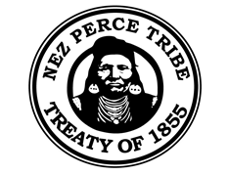
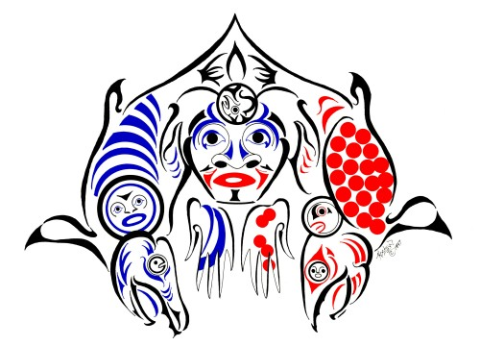

65th ANNUAL
NORTHWEST FISH CULTURE CONFERENCE
REGISTRATION MAIL-IN FORM

NAME_____________________________________________

BUSINESS NAME__________________________________________________________

EMAIL ADDRESS_______________________________________________________

MAILING ADDRESS_____________________________________________________

CITY_____________________________STATE_____________ZIP______________

TELEPHONE #_______________________ FAX#______________________

COST (includes 1 social ticket) _____@$110 = _________
EXTRA SOCIAL TICKETS _____@ $30 = _________

TOTAL _________

MAKE CHECKS PAYABLE TO:
CTUIR
Memo: NWFCC 2014

SEND REGISTRATON FORM TO:

Margaret Anderson – Registration Coordinator
NWFCC
1387 S. Vinnell Way, Suite 343
Boise, ID 83709-1657
margaret_m_anderson@fws.gov
PH # 208-378-5299 FAX # 208-378-5304

