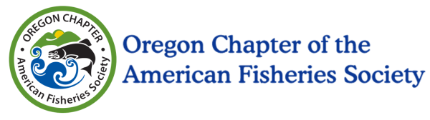
OR AFS Education Materials and Participation Grant
Award amount: Up to $1,000
Grant Deadline: Sunday March 11, 2018
Questions and Contact: Ryan.D.Battleson@state.or.us

The Oregon Chapter of the American Fisheries Society (OR AFS) is proud to announce the opportunity to apply for education materials and participation grants, up to $1000 each. A total of $2000 is available for awards. These grants are intended for educators that teach fisheries or aquatic related sciences to grade levels k-12 in the State or Oregon. Funds can be used for any education related materials or participation activities having to do with fisheries biology and aquatic related sciences, and will be evaluated on how well they meet the below education goals. These include gear (waders, nets, instruments, aquariums), educational signage, restoration supplies, curriculum development, bus services for fields trips, or other teaching needs.

Consistent with the National Chapter’s guide to fisheries education for grades k-12, applications will be evaluated based on how well each meets the following criteria:

Goal 1. Help youth acquire a basic awareness and understanding of the total ecosystem in which fishes live; the commercial, sport, and subsistence fisheries supported by that ecosystem; the issues involved in managing these fisheries; and the effects people can and do have on the resource.
Goal 2. Help youth acquire positive attitudes and values toward fishes, fishing, fisheries, and the aquatic ecosystem in general, ensuring their protection, rehabilitation, and responsible management.
Goal 3. Help youth acquire the social and technical skills to make decisions and solve problems associated with the management of fisheries and the motivation to personally act on those problems. Provide youth with opportunities for personal action and evaluation of those actions.

To apply:
Please submit a brief description of your experience and programs you intend to or are currently teaching to grades k-12, how these programs fit with any of the goals above, brief itemization of what the funds will be spent on, and send to Ryan.D.Battleson@state.or.us by the grant deadline.

Strong preference will be given to applicants that have collaborative partners, plan for implementation including administrative support, clearly incorporate Next Generation Science Standards, include match funding, involve field experience (outside the classroom), contribute towards the purchasing of gear or other durable goods, and have potential to benefit multiple students.

Applicants will be awarded the funds after the annual meeting of the Oregon Chapter of American Fisheries Society Annual Meeting in March 2018. A project completion report detailing how OR AFS funds were spent shall be completed by July 31, 2018.

For more information about the Oregon Chapter of the American Fisheries Society, please visit: http://orafs.org/

