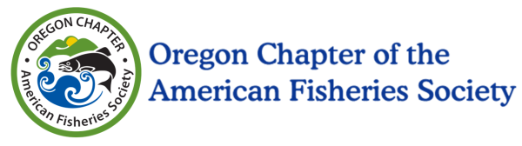
OR AFS Educators Travel Award Scholarship

Award Amount: $500 travel reimbursement

Scholarship Deadline: January 8, 2017 11:59 pm

Contact: Ryan.d.battleson@state.or.us

The Oregon Chapter of the American Fisheries Society (OR AFS) is proud to announce the opportunity for two educator travel award scholarships. These scholarships are intended to reimburse educators up to $500 dollars for their travel accommodations while attending the Annual Meeting of the Oregon Chapter of the American Fisheries Society from February 28-March 3, 2017, in beautiful Bend, Oregon. This year’s theme is Casting a Broader Net: Increasing Diversity and Inclusion in the Fisheries Profession.

This is a wonderful opportunity to attend one of the nation’s oldest professional organizations, network and learn more about the current status of fisheries, aquatic science, riparian restoration, education and outreach opportunities in the State of Oregon. We are expecting a strong turnout of over 400 fisheries and aquatic resources professionals. Many teachers often find themselves working with these professionals to bring real world applications into their classrooms for the next generation of natural resource professionals.

More information about the current, and past meetings can be found at the OR AFS website:
http://orafs.org/2017-annual-meeting-of-the-oregon-chapter-of-the-american-fisheries-society/

To be eligible you must:

Be an educator teaching grade levels k-12 in Oregon
Apply by January 8
Plan on attending all or part of the annual meeting in Bend for 2017
Submit a letter describing why you would like to attend

Successful applicants will be notified prior to the January 27 early registration deadline.

